APS 502: Financial Engineering

Project Assignment

Yuyang Shao 1002961636

**Q1 P1:**

From the spots rates given, we can derive the forward rates:

F(1,2) = 0.02

F(2,3) = 0.03

F(3,4) = 0.04

F(4,5) = 0.05

F(5,6) = 0.06

We can then use the forward rates to carry the cash left of each period forward.

The problem can be formulated as follows:

minimize

108x1 + 94x2 + 99x3 + 92.7x4 + 96.6x5 + 95.9x6 + 92.9x7 + 110x8 + 104x9 + 101x10 + 107x11 + 102x12 + 95.2x13

subject to:

10x1 + 7x2 + 8x3 + 6x4 + 7x5 + 6x6 + 5x7 + 10x8 + 8x9 +6x10 +10x11 + 7x12 + 100x13 - z1 ≥ 500;

10x1 + 7x2 + 8x3 + 6x4 + 7x5 + 6x6 + 5x7 + 10x8 + 8x9 +6x10 +110x11 + 107x12 + 1.02z1 - z2 ≥ 200 ;

10x1 + 7x2 + 8x3 + 6x4 + 7x5 + 6x6 + 5x7 + 110x8 +108x9 +106x10 + 1.03z2 - z3 ≥ 800;

10x1 + 7x2 + 8x3 + 6x4 + 7x5 + 106x6 + 105x7 + 1.04z3 - z4 ≥ 400;

10x1 + 7x2 + 8x3 + 106x4 + 107x5 + 1.05z4 - z5 ≥ 700;

110x1 + 107x2 + 108x3 + 1.06z5 ≥ 900;

Where xi ≥ 0; xj ≥ 0 (i = 1..13; j = 1..5)

**Q1 P2,P3:**

Forthese 2 parts, we just need one more constraint each to complete the linear programming problem.

P2:

108x1 + 94x2 + 99x3 + 92.7x4 + 96.6x5 + 95.9x6 ≤ 0.5(108x1 + 94x2 + 99x3 + 92.7x4 + 96.6x5 + 95.9x6 + 92.9x7 + 110x8 + 104x9 + 101x10 + 107x11 + 102x12 + 95.2x13);

P3:

108x1 + 94x2 + 99x3 + 92.7x4 + 96.6x5 + 95.9x6 ≤ 0.25(108x1 + 94x2 + 99x3 + 92.7x4 + 96.6x5 + 95.9x6 + 92.9x7 + 110x8 + 104x9 + 101x10 + 107x11 + 102x12 + 95.2x13);

**Q1 Results and code:**

P1:

c = [108, 94, 99, 92.7,96.6,95.9,92.9,110,104,101, 107,102,95.2,0,0,0,0,0]

A = -[10,7,8,6,7,6,5,10,8,6,10,7,100,-1,0,0,0,0;

10,7,8,6,7,6,5,10,8,6,110,107,0,1.02,-1,0,0,0;

10,7,8,6,7,6,5,110,108,106,0,0,0,0,1.03,-1,0,0;

10,7,8,6,7,106,105,0,0,0,0,0,0,0,0,1.04,-1,0;

10,7,8,106,107,0,0,0,0,0,0,0,0,0,0,0,1.05,-1;

110,107,108,0,0,0,0,0,0,0,0,0,0,0,0,0,0,1.06]

b = -[500,200,800,400,700,900]

Aeq = []

beq = []

lb = [0,0,0,0,0,0,0,0,0,0,0,0,0,0,0,0,0,0]

ub = [inf,inf,inf,inf,inf,inf,inf,inf,inf,inf,inf,inf,inf,inf,inf,inf,inf,inf]

[x,fval] = linprog(c,A,b,Aeq,beq,lb,ub)

x = [8.1818, 0 ,0 ,0 , 5.7774 ,2.6202 ,0 , 0 , 6.1298 ,0 ,0.1180 ,0 , 3.1180]

z=[0,0,0,0,0]

fval =2.6400e+03

P2:

c = [108, 94,99,92.7,96.6,95.9,92.9,110,104,101, 107,102,95.2,0,0,0,0,0]

A = -[10,7,8,6,7,6,5,10,8,6,10,7,100,-1,0,0,0,0;

10,7,8,6,7,6,5,10,8,6,110,107,0,1.02,-1,0,0,0;

10,7,8,6,7,6,5,110,108,106,0,0,0,0,1.03,-1,0,0;

10,7,8,6,7,106,105,0,0,0,0,0,0,0,0,1.04,-1,0;

10,7,8,106,107,0,0,0,0,0,0,0,0,0,0,0,1.05,-1;

110,107,108,0,0,0,0,0,0,0,0,0,0,0,0,0,0,1.06;

-108,-94,-99,-92.7,-96.6,-95.9,92.9,110,104,101,107,102, 95.2,0,0,0,0,0]

%-108*0.5,-94*0.5,-99*0.5,-92.7*0.5,-96.6*0.5,- %95.9*0.5,92.9*0.5,110*0.5,104*0.5,101* %0.5,107*0.5,102*0.5,95.2*0.5,0,0,0,0,0]

b = -[500,200,800,400,700,900,0]

Aeq = []

beq = []

lb = [0,0,0,0,0,0,0,0,0,0,0,0,0,0,0,0,0,0]

ub = [inf,inf,inf,inf,inf,inf,inf,inf,inf,inf,inf,inf,inf,inf,inf,inf,inf,inf]

[x,fval] = linprog(c,A,b,Aeq,beq,lb,ub)

x = [0,8.4112 ,0 ,0,5.5027 ,0,3.3566 ,0 ,6.3502 ,0 ,0.3183 ,0 ,3.3183]

z = [ 0 ,0,0 ,49.8396 ,0]

fval =2.6444e+03

P3:

c = [108, 94, 99, 92.7,96.6,95.9,92.9,110,104,101,107, 102,95.2,0,0,0,0,0];

A = -[10,7,8,6,7,6,5,10,8,6,10,7,100,-1,0,0,0,0;

10,7,8,6,7,6,5,10,8,6,110,107,0,1.02,-1,0,0,0;

10,7,8,6,7,6,5,110,108,106,0,0,0,0,1.03,-1,0,0;

10,7,8,6,7,106,105,0,0,0,0,0,0,0,0,1.04,-1,0;

10,7,8,106,107,0,0,0,0,0,0,0,0,0,0,0,1.05,-1;

110,107,108,0,0,0,0,0,0,0,0,0,0,0,0,0,0,1.06;

-108*0.75,-94*0.75,-99*0.75,-92.7*0.75,-96.6*0.75,-95.9*0.75,92.9*0.25,110*0.25,104*0.25,101*0.25,107*0.25,102*0.25,95.2*0.25,0,0,0,0,0] ;

b = -[500,200,800,400,700,900,0];

Aeq = [];

beq = [];

lb = [0,0,0,0,0,0,0,0,0,0,0,0,0,0,0,0,0,0];

ub = [inf,inf,inf,inf,inf,inf,inf,inf,inf,inf,inf,inf,inf,inf,inf,inf,inf,inf];

[x,fval] = linprog(c,A,b,Aeq,beq,lb,ub)

x =[0,7.1271 ,0 ,0 ,0 ,0,10.4068,0,6.4637 ,0 ,0.4215 ,0,3.4215]

z = [ 0 ,0 ,0 ,742.6027,129.6225]

fval =2.6798e+03

**Interpretation:**

Based on the fval calculated, we can see that portfolio 3 costs the most, portfolio 2 costs the second most, and portfolio 1 costs the least. We may conclude that the less you are allowed to put into the B rating bonds, the more the portfolio costs.

**Q2 P1(a):**

The basic statistics for adjusted closing prices of SPY, GOVT, and EEMV from Jan 2014 to end of Jan 2022:

|  |  |  |  |
| --- | --- | --- | --- |
| Stocks/Assets | SPY | GOVT | EEMV |
| Arithmetic  Average | 0.011577 | 0.002009 | 0.003444 |
| Geometric  Average | 0.010779 | 0.001948 | 0.002782 |
| Standard  Deviation | 0.040117 | 0.011159 | 0.036398 |

The covariance matrix:

|  |  |  |  |
| --- | --- | --- | --- |
| covariance | SPY | GOVT | EEMV |
| SPY | 0.001609 | -0.000114 | 0.001014 |
| GOVT | -0.000114 | 0.000125 | -0.000057 |
| EEMV | 0.001014 | -0.000057 | 0.001325 |

**Q2 P1(b):**

**Results and code:**

Q = [0.001609, -0.000114, 0.001014;

-0.000114, 0.000125, -0.000057;

0.001014, -0.000057, 0.001325;];

n = 3;

c = zeros(n,1);

A = -[0.010779,0.001948,0.002782]

%b = -[];

Aeq = [ones(1,n)]%[1,1,1];

beq = [1];

ub = [inf;inf;inf;];

%for short selling

lb = [-inf;-inf;-inf;]

%without short selling:

%lb = [0;0;0;]

goal_R = linspace(0.002,0.01,10)

%goal_R=[0.003:0.000856:0.0107]; % expected return goals

x = zeros(length(goal_R),n);

std_devi = zeros(length(goal_R),1)

variance = zeros(length(goal_R),1)

for a=1:length(goal_R)

b = -goal_R(a)

[x(a,:), fval(a,1)] = quadprog(Q, c, A,b, Aeq,beq, lb,ub);

std_devi(a,1)=(x(a,:)*Q*x(a,:)')^.5;

% standard deviation = (x'*Q*x)^.5

variance(a,1)=x(a,:)*Q*x(a,:)';

end

plot(std_devi, goal_R, '-k*')

xlabel('volatility \sigma')

ylabel('expected return goal R')

title('The efficient frontier of MVO')

**If we allow short selling(w can be negative):**

**(W1:SPY, W2:GOVT, W3:EEMV)**

|  |  |  |  |  |
| --- | --- | --- | --- | --- |
| Target return | w1 | w2 | w3 | variance |
| 0.002 | 0.1001 | 0.8674 | 0.0325 | 0.00009516 |
| 0.0028889 | 0.1046 | 0.8664 | 0.0290 | 0.00009517 |
| 0.0037778 | 0.2124 | 0.8428 | -0.0552 | 0.00010613 |
| 0.0046667 | 0.3211 | 0.8190 | -0.1400 | 0.00013763 |
| 0.0055556 | 0.4298 | 0.7951 | -0.2249 | 0.00018969 |
| 0.0064444 | 0.5384 | 0.7713 | -0.3098 | 0.00026227 |
| 0.0073333 | 0.6471 | 0.7475 | -0.3946 | 0.0003554 |
| 0.0082222 | 0.7558 | 0.7237 | -0.4795 | 0.00046907 |
| 0.0091111 | 0.8644 | 0.6999 | -0.5643 | 0.0006033 |
| 0.01 | 0.9731 | 0.6761 | -0.6492 | 0.00075805 |

**The corresponding efficient frontier:**

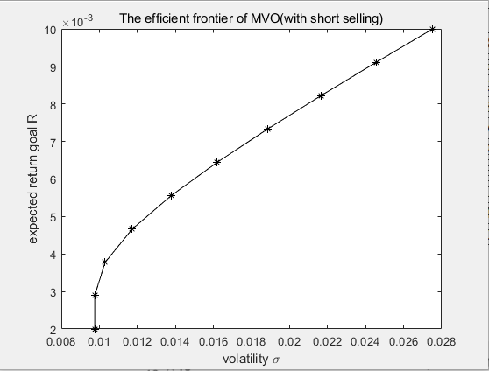

**If we do not allow short selling(w ≥** **0):**

(w3 does have some weights for the last 7 portfolio, but they are too small that we cannot view it if we let the result remain 4 decimal places. One way to show their weights is to add “format long” or “format shortg” at the beginning of the matlab file. But this can make the result messy(around 10 decimal places))

|  |  |  |  |  |
| --- | --- | --- | --- | --- |
| Target return | w1 | w2 | w3 | variance |
| 0.002 | 0.1000 | 0.8673 | 0.0326 | 0.00009516 |
| 0.0028889 | 0.1044 | 0.8664 | 0.0291 | 0.00009517 |
| 0.0037778 | 0.2072 | 0.7927 | 0.0001 | 0.00011021 |
| 0.0046667 | 0.3079 | 0.6921 | 0.0000 | 0.00016379 |
| 0.0055556 | 0.4085 | 0.5915 | 0.0000 | 0.00025717 |
| 0.0064444 | 0.5092 | 0.4908 | 0.0000 | 0.00039027 |
| 0.0073333 | 0.6098 | 0.3902 | 0.0000 | 0.00056314 |
| 0.0082222 | 0.7105 | 0.2895 | 0.0000 | 0.00077577 |
| 0.0091111 | 0.8111 | 0.1889 | 0.0000 | 0.0010282 |
| 0.01 | 0.9118 | 0.0882 | 0.0000 | 0.0013203 |

**The corresponding efficient frontier:**

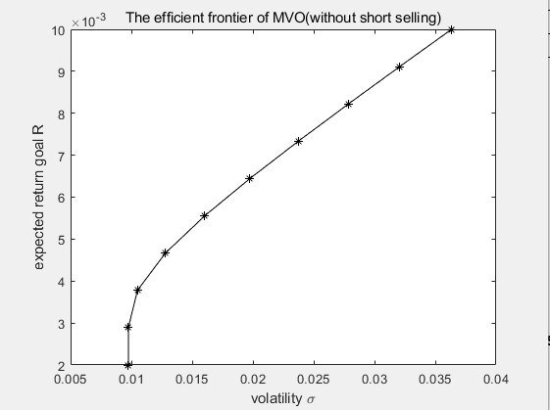

**Q2 P1(c):**

**The monthly returns of Feb 2022 for the 3 assets are as follows:  
SPY:-0.02952**

**GOVT:-0.00772**

**EEMV:-0.00112**

|  |  |  |  |  |
| --- | --- | --- | --- | --- |
|  | **P1:Minimum variance portfolio with short selling(10.01% SPY, 86.74% GOVT, 3.25% EEMV)** | **P2:Minimum variance portfolio without short selling(10% SPY, 86.73% GOVT,3.26% EEMV)** | **P3:Portfolio with 70% SPY, 20% GOVT, 10% EEMV** | **P4:Equally weighted portfolio**  **(all 1/3)** |
| **return** | **-0.009688** | **-0.009684** | **-0.02232** | **-0.012787** |

**Interpretation: The returns for all 3 assets in February are negative. So all portfolios have negative returns but some helps to minimize the loss. If we rank the returns of the 4 portfolio, we have p2>p1>p4>p3. We can clearly see that SPY has much larger negative returns than the other 2 assets, so if a portfolio put a larger weight on SPY, this portfolio must have a lower return. And this is actually true here for the 4 portfolio returns we calculated. The standard deviations(risk,volatility) for the 3 assets are 0.04(SPY), 0.01(GOVT) and 0.036(EEMV). So it is not hard to see that a person holding a portfolio with more weights on SPY and EEMV will bear much higher risk(eg.p3) and holding portfolio with more weight on GOVT will bear much lower risk(ag. p1,p2). If one wants higher returns, he has to bear higher risks. This is true especially in our situation here when all the returns of the assets are negative and we want to hedge the risk. If a person is risk averse, he will choose p2 so that he will have a small loss. But if he is a risk seeker, he may choose p3 and he will suffer comparatively bigger losses.**

**Q2 P2:**

**Similar to P1(a), we calculate the following statistics:**

|  |  |  |  |  |  |
| --- | --- | --- | --- | --- | --- |
| Stocks/assets | ACN | BR | CBOE | CME | ICE |
| Arithmetic Average | 0.018421 | 0.017721 | 0.011821 | 0.015792 | 0.013322 |
| Geometric Average | 0.016701 | 0.016015 | 0.009665 | 0.014357 | 0.011825 |
| Standard Deviation | 0.059091 | 0.059232 | 0.065333 | 0.054294 | 0.055712 |

The covariance matrix:

|  |  |  |  |  |  |  |  |  |
| --- | --- | --- | --- | --- | --- | --- | --- | --- |
|  | SPY | GOVT | EEMV | ACN | BR | CBOE | CME | ICE |
| SPY | 0.001609 | -0.000114 | 0.001014 | 0.001893 | 0.001482 | 0.000940 | 0.000816 | 0.001274 |
| GOVT | -0.000114 | 0.000125 | -0.000057 | -0.000061 | 0.000033 | -0.000017 | -0.000121 | -0.000086 |
| EEMV | 0.001014 | -0.000057 | 0.001325 | 0.000926 | 0.000891 | 0.000323 | 0.000192 | 0.000392 |
| ACN | 0.001893 | -0.000061 | 0.000926 | 0.003492 | 0.002259 | 0.001281 | 0.001069 | 0.001869 |
| BR | 0.001482 | 0.000033 | 0.000891 | 0.002259 | 0.003508 | 0.001046 | 0.001112 | 0.001446 |
| CBOE | 0.000940 | -0.000017 | 0.000323 | 0.001281 | 0.001046 | 0.004268 | 0.001924 | 0.001670 |
| CME | 0.000816 | -0.000121 | 0.000192 | 0.001069 | 0.001112 | 0.001924 | 0.002948 | 0.001837 |
| ICE | 0.001274 | -0.000086 | 0.000392 | 0.001869 | 0.001446 | 0.001670 | 0.001837 | 0.003104 |

**The corresponding code is as follows:**

Q = [0.001609, -0.000114, 0.001014, 0.001893, 0.001482, 0.000940, 0.000816, 0.001274;

-0.000114, 0.000125, -0.000057, -0.000061, 0.000033, -0.000017, -0.000121, -0.000086;

0.001014, -0.000057, 0.001325, 0.000926, 0.000891, 0.000323, 0.000192, 0.000392;

0.001893, -0.000061, 0.000926, 0.003492, 0.002259, 0.001281, 0.001069, 0.001869;

0.001482, 0.000033, 0.000891, 0.002259, 0.003508, 0.001046, 0.001112, 0.001446;

0.000940, -0.000017, 0.000323, 0.001281, 0.001046, 0.004268, 0.001924, 0.001670;

0.000816, -0.000121, 0.000192, 0.001069, 0.001112, 0.001924, 0.002948, 0.001837;

0.001274, -0.000086, 0.000392, 0.001869, 0.001446, 0.001670, 0.001837, 0.003104;];

n = 8;

c = zeros(n,1);

A = -[0.010779,0.001948,0.002782,0.016701,0.016015,0.009665,0.014357,0.011825];

%b = -[];

Aeq = [ones(1,n)]%[1,1,1];

beq = [1];

ub = [inf;inf;inf;inf;inf;inf;inf;inf;];

%for short selling

lb = [-inf;-inf;-inf;-inf;-inf;-inf;-inf;-inf;]

%without short selling:

%lb = [0;0;0;0;0;0;0;0]

goal_R=linspace(0.002,0.0167,10);

%goal_R=[0.002:0.00147:0.0167]; % expected return goals

x = zeros(length(goal_R),n);

std_devi = zeros(length(goal_R),1)

variance = zeros(length(goal_R),1)

for a=1:length(goal_R)

b = -goal_R(a)

[x(a,:), fval(a,1)] = quadprog(Q, c, A,b, Aeq,beq, lb,ub);

std_devi(a,1)=(x(a,:)*Q*x(a,:)')^.5;

% standard deviation = (x'*Q*x)^.5

variance(a,1)=x(a,:)*Q*x(a,:)';

end

plot(std_devi, goal_R, '-k*')

xlabel('volatility \sigma')

ylabel('expected return goal R')

title('The efficient frontier of MVO')

**If we allow short selling(w can be negative):**

**(W1:SPY, W2:GOVT, W3:EEMV, W4:ACN, W5:BR, W6:CBOE, W7:CME, W8:ICE)**

|  |  |  |  |  |  |  |  |  |  |
| --- | --- | --- | --- | --- | --- | --- | --- | --- | --- |
| Target return | W1 | W2 | W3 | W4 | W5 | W6 | W7 | W8 | variance |
| 0.002 | 0.1643 | 0.8554 | 0.0276 | -0.0360 | -0.0514 | -0.0197 | 0.0612 | -0.0014 | 0.000080168 |
| 0.0036333 | 0.2041 | 0.8316 | -0.0233 | -0.0208 | -0.0344 | -0.0253 | 0.0852 | -0.0171 | 0.000087072 |
| 0.0052667 | 0.2788 | 0.7870 | -0.1187 | 0.0078 | -0.0026 | -0.0358 | 0.1301 | -0.0466 | 0.00013715 |
| 0.0069 | 0.3535 | 0.7424 | -0.2141 | 0.0363 | 0.0292 | -0.0463 | 0.1750 | -0.0760 | 0.00023568 |
| 0.0085333 | 0.4282 | 0.6979 | -0.3094 | 0.0648 | 0.0609 | -0.0568 | 0.2199 | -0.1055 | 0.00038263 |
| 0.010167 | 0.5029 | 0.6533 | -0.4048 | 0.0934 | 0.0927 | -0.0673 | 0.2648 | -0.1350 | 0.00057803 |
| 0.0118 | 0.5776 | 0.6087 | -0.5002 | 0.1219 | 0.1245 | -0.0778 | 0.3097 | -0.1644 | 0.00082188 |
| 0.013433 | 0.6523 | 0.5642 | -0.5956 | 0.1504 | 0.1563 | -0.0883 | 0.3546 | -0.1939 | 0.0011141 |
| 0.015067 | 0.7270 | 0.5196 | -0.6910 | 0.1789 | 0.1881 | -0.0988 | 0.3995 | -0.2233 | 0.0014549 |
| 0.0167 | 0.8017 | 0.4750 | -0.7864 | 0.2075 | 0.2198 | -0.1093 | 0.4444 | -0.2528 | 0.001844 |

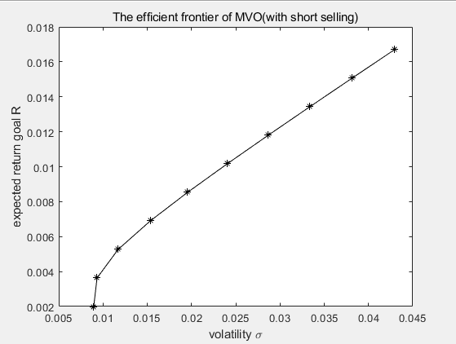

**If we do not allow short selling(w ≥ 0):**

**(W1:SPY, W2:GOVT, W3:EEMV, W4:ACN, W5:BR, W6:CBOE, W7:CME, W8:ICE)**

|  |  |  |  |  |  |  |  |  |  |
| --- | --- | --- | --- | --- | --- | --- | --- | --- | --- |
| Target return | W1 | W2 | W3 | W4 | W5 | W6 | W7 | W8 | variance |
| 0.002 | 0.0604 | 0.8430 | 0.0515 | 0.0000 | 0.0000 | 0.0000 | 0.0451 | 0.0000 | 9.0099e-05 |
| 0.0036333 | 0.1087 | 0.8231 | 0.0105 | 0.0000 | 0.0000 | 0.0000 | 0.0578 | 0.0000 | 9.3573e-05 |
| 0.0052667 | 0.1324 | 0.7029 | 0.0000 | 0.0387 | 0.0088 | 0.0000 | 0.1172 | 0.0000 | 0.00015362 |
| 0.0069 | 0.0961 | 0.5974 | 0.0000 | 0.0945 | 0.0476 | 0.0000 | 0.1643 | 0.0000 | 0.00028104 |
| 0.0085333 | 0.0598 | 0.4920 | 0.0000 | 0.1504 | 0.0863 | 0.0000 | 0.2115 | 0.0000 | 0.0004721 |
| 0.010167 | 0.0236 | 0.3865 | 0.0000 | 0.2061 | 0.1251 | 0.0000 | 0.2586 | 0.0000 | 0.00072682 |
| 0.0118 | 0.0000 | 0.2762 | 0.0000 | 0.2563 | 0.1628 | 0.0000 | 0.3047 | 0.0000 | 0.0010453 |
| 0.013433 | 0.0000 | 0.1568 | 0.0000 | 0.2959 | 0.1984 | 0.0000 | 0.3488 | 0.0000 | 0.0014287 |
| 0.015067 | 0.0000 | 0.0374 | 0.0000 | 0.3355 | 0.2340 | 0.0000 | 0.3929 | 0.0000 | 0.0018774 |
| 0.0167 | 0.0000 | 0.0000 | 0.0000 | 0.9985 | 0.0015 | 0.0000 | 0.0000 | 0.0000 | 0.0034884 |

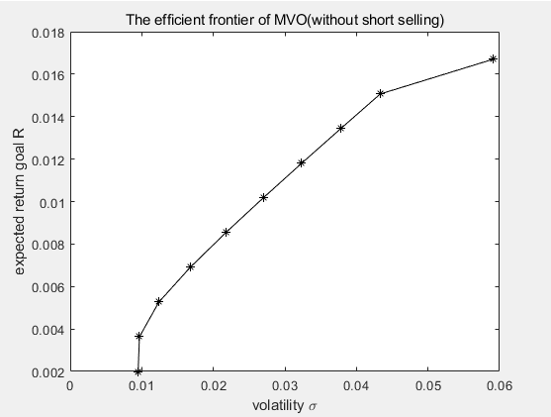

**Interpretation:**

**With more asset choices, we are able to create portfolios that can bring us more portfolio return but also at a relatively higher risk level. With short selling, we are able to obtain the same expected return(as the system without short selling) but at a lower risk level.**